Docker Private Registries (local)

**Docker Registries**

Docker registries are repositories similar to github where we can store our docker images in our own machines where docker is installed. These repositories can be accessed from client machines from where we can push/pull docker images.

**Prerequisites:**

1. A server machine with docker installed, will act as repository machine.
2. A client machine with docker installed , will act as client which will push/pull image to and from the registry.
3. Both machines should have access to each other.

**In Registry Machine**

1. Crete a docker registry. Run the following command to create a registry.

|  |
| --- |
| docker run -d -p 5000:5000 --restart=always --name registry registry:2 |

This will download a docker image of the registry and will run in the background.

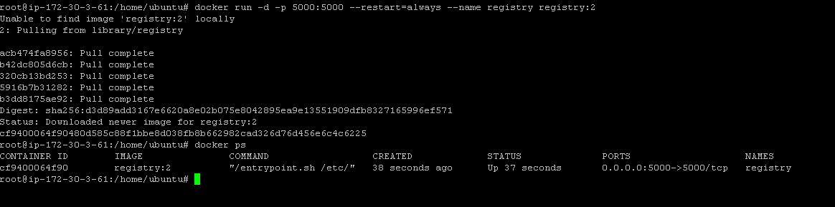

1. Tag any image to point to your registry. Your registry will be running in localhost:5000. You can replace localhost with your ip or domain name so that the registry can be accessed from other machines.

|  |
| --- |
| docker tag <imagename> <ip/domain>:5000/<imagename> |

Eg: docker tag hello-world 54.83.186.109:5000/hello-world

1. Push your image to the repository/registry, run the command.

|  |
| --- |
| docker push <imagename> <ip/domain>:5000/<imagename> |

Eg: docker push 54.83.186.109:5000/hello-world

You will get the below error if we use ip/domain instead of localhost to push the image.

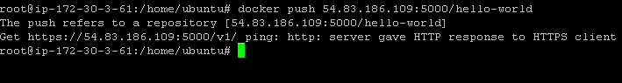

1. So, we have to add --insecure-registry to docker-daemon. Run the following command to do so. Stop the docker and add --insecure registry.

|  |
| --- |
| service docker stop |
| docker daemon --insecure-registry <serverip>:5000 |

Eg: docker daemon --insecure-registry 54.83.186.109:5000

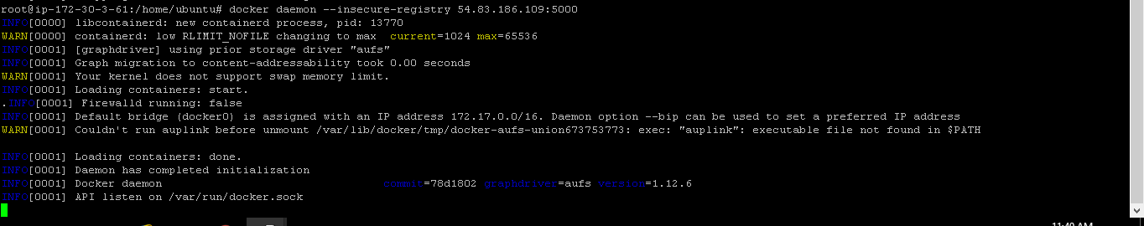

1. Now again execute the command to push the image in another terminal.

|  |
| --- |
| docker tag <imagename> <ip/domain>:5000/<imagename> |

Eg: docker tag hello-world 54.83.186.109:5000/hello-world

Now, the image will get pushed to the local registry.

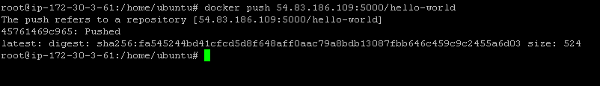

1. We can pull the image from the registry. Use docker pull command to pull image from the repository.

|  |
| --- |
| docker pull <ip/domain>:5000/<imagename> |

Eg: docker pull 54.83.186.109:5000/hello-world

So now we are able to push and pull image from private docker registry running within the server machine.

**From Client Machine**

Inorder for the client machine to push/pull from the private docker registry running in the server machine we need to configure the --insecure-registry in client machine also. Follow the steps .

1. Try to pull the image from the private docker registry.

|  |
| --- |
| docker pull <server-ip:5000>/<imagename> |

Eg: docker pull 54.83.186.109:5000/hello-world

You will get error from client as shown below.

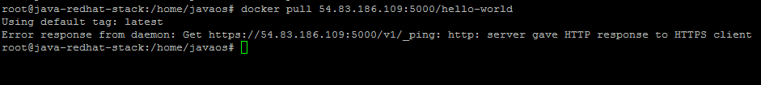

1. Add --insecure-registry to the client machine to allow client to connect .

|  |
| --- |
| service docker stop |
| docker daemon --insecure-registry <server-ip:5000> |

Eg: docker daemon --insecure-registry 54.83.186.109:5000

1. Now pull image from the repository.

|  |
| --- |
| docker pull <server-ip:5000>/<imagename> |

Eg: docker pull 54.83.186.109:5000/hello-world

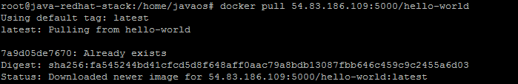

**Conclusion:**

We have created a private docker registry in a server machine and we have configured a client machine from where we can push/pull docker image to and from the private registry in server machine. We can configure as many number of client machines to access the private registry.